WELLNESS WHEEL
Adopting a wellness philosophy can greatly impact behaviors, emotions and relationships. Practicing personal wellness can improve quality of life and maximize an individual’s full potential.
The term ‘wellness’ is multi-faceted and encompasses the eight categories below. Wellness is a skill that everyone can learn and practice.
These eight sections represent dimensions of your life and help you identify areas where we may be out of balance. How full do you feel each dimension is for you, in this moment? Rank your satisfaction with each dimension.
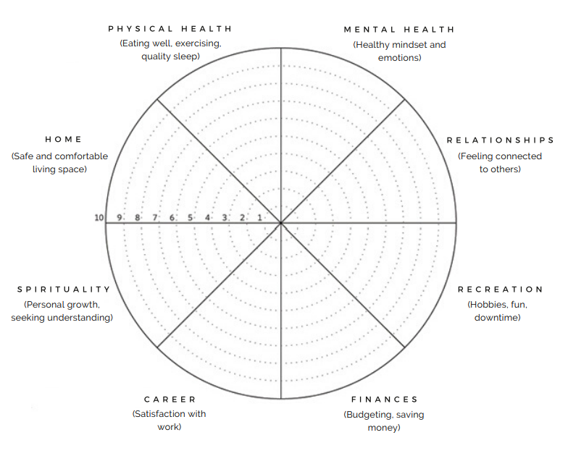
- What do you notice? What contributes to the level of each category?

- Which are a priority to you right now? How satisfied are you with where they are?

- Which areas do you want to focus on improving? What does that look like?

